Route 1 EBairport-Bathgate-Airdrie-Glasgow
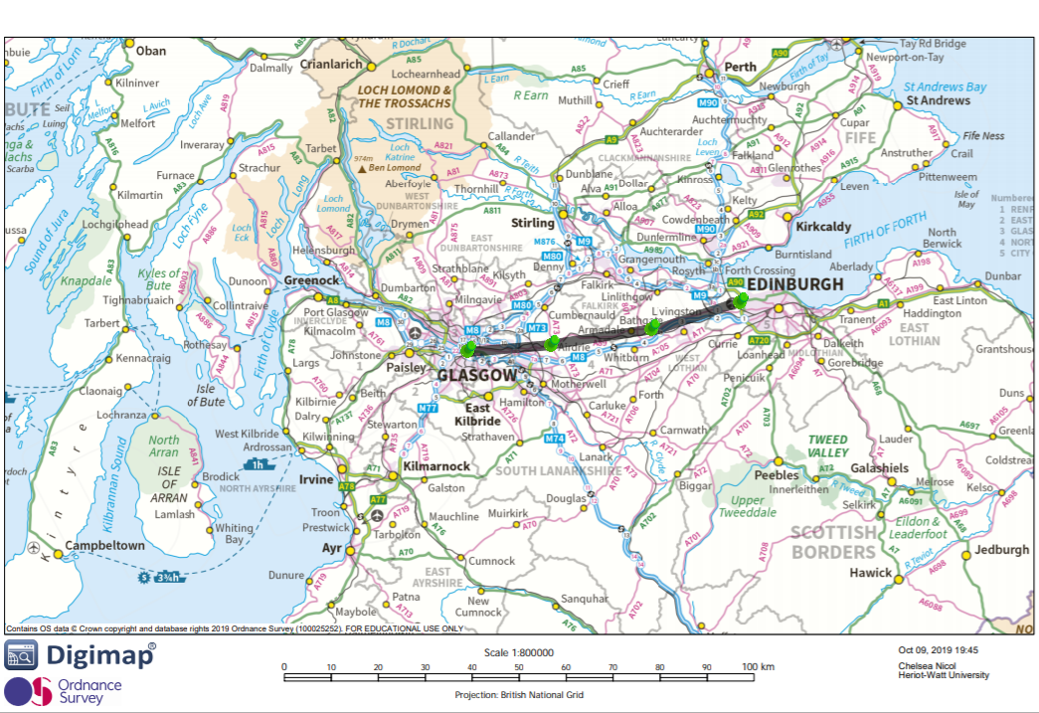
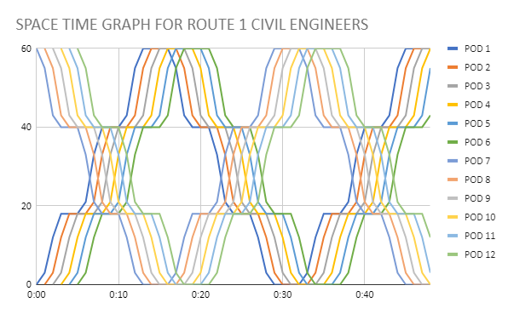
Space time graph for route 1 with 4 stops and a 2 minute safety distance between pods. Since pods spend some time accelerating a 2 minute safety distance can be achieved while sending in a new pod every minute.
- Route has 4 stops: Edinburgh airport>Bathgate>Airdrie>Glasgow Central.
- The idea behind introducing various calling points is to make travelling more convenient for passengers who live and travel between glasgow and Edinburgh.
- Initial and final part of the route are below ground. This is to avoid built up areas and above ground traffic (planes). Central section is above ground in rural areas.

Pros
- Partial above ground route reduces tunneling and associated costs
- Several stops allow for more people to access route
- Very direct route only a few stops
- Shorter track, easier construction, less material used, this results in the cost of construction becoming cheaper
- Underground inside built up areas, does not interfere with existing structures.

Cons
- Going up and down can cause discomfort for passengers
- Top speed is reduced due to the fact that the pods cannot reach its max speed before it has to decelerate again.
- Route 1 is more direct than route 3.
- Has to accelerate/decelerate more often with more stops. More energy spent.
- Less stations required as compared to route 3.
- Harder to construct as the route is away from transport links. Tubes not easy to transport off roads leading to a higher carbon footprint

Route 1 Direct service

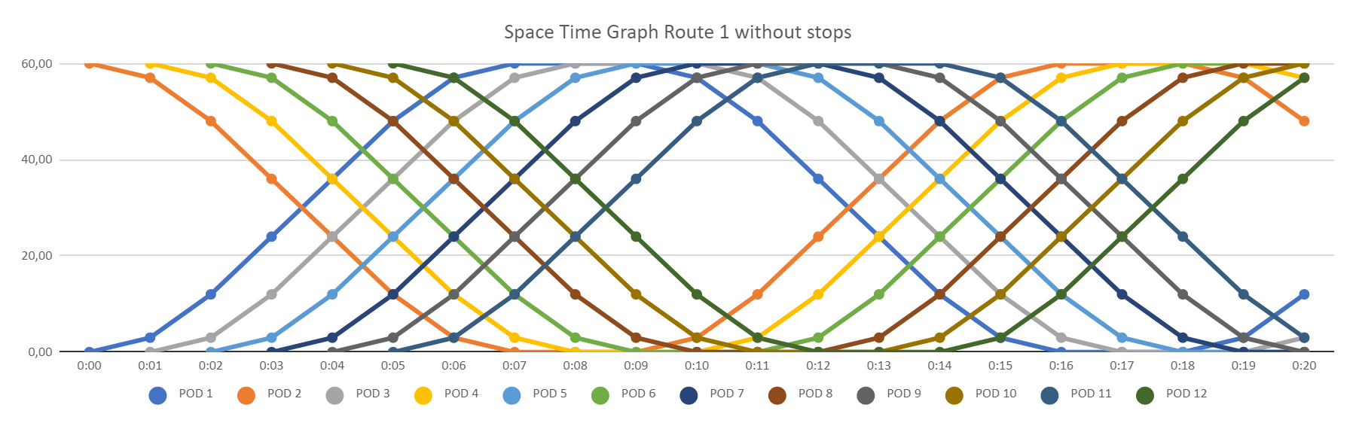

Space time graph Route 2 without stops can be run during certain hours of the day to ensure efficiency.

Pros
- This route is significantly faster than route 2 and 3 (from the suggested graphs it indicates that it can cover almost 3 cycles in the same amount of time as route 3 covers 1 cycle)
- The more direct route ensures that the system coasts for as long as possible which results in less energy being wasted leading to a reduced carbon emissions and greater efficiency
- This method is also cost effective as it means that the whole route is not under ground meaning that it will not have large excavation costs. This would mean that less time would be spent working in an environment underground meaning there would be less threat to life.
- It is underground in urban areas to avoid excavation of soil that existing infrastructure is dependent on.
- This method ensures that there is less cost running other stations at all times.
- If this was considered a permanent direct route we would not need to construct other stations at other stops.

Cons
- This route would be covering less people i.e the people from Bathgate or Airdrie would be less likely to travel via our proposed project.
- In rural areas, harder to transport tube to site.
- Going up and down can cause discomfort for passengers
- Above ground will take up some fields and green space, possible demolition of existing structures.
- Above ground destroys the scenery, comes into conflict with locals.

Route 2 Edinburgh-Falkirk-Glasgow
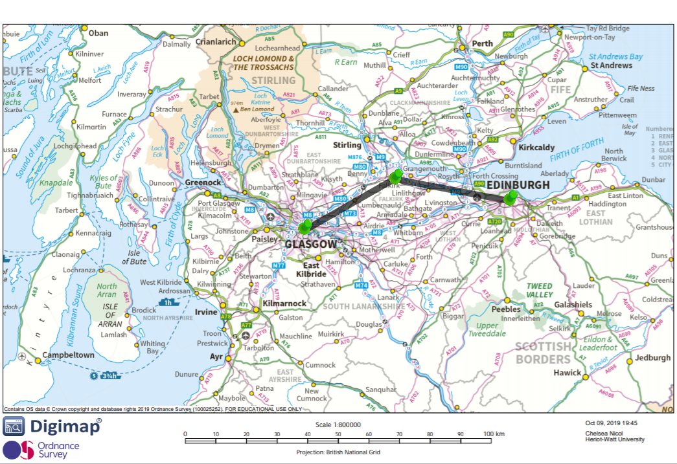
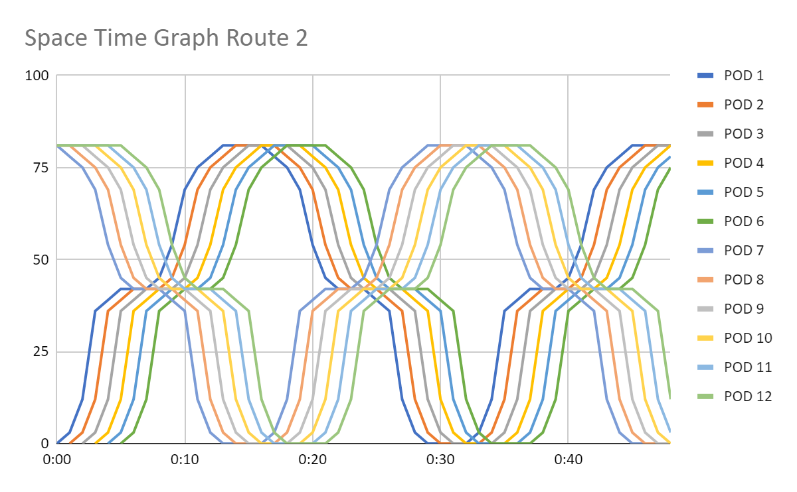
Route 2 stopping once at Falkirk between Glasgow and Edinburgh

This route will be entirely underground. This allows us to build straight tunnels with no elevation differences to ease the pods into reaching maximum speed and coast along the route. We will also avoid conflicts with residential areas and ruining the sightline of the landscape. By diverting to Falkirk we provide an additional stop in the middle of the central belt which will provide customers with more flexibility and choice. The route will terminate at Glasgow and Edinburgh city centre, providing more transport links and integrating our proposed project into existing networks.

Pros:
- No external disruptions to operations e.g. weather, obstructions.
- Non-intrusive to the views and landscapes.
- Smooth ride for passengers
- Allows for most efficient use of power. Being able to accelerate to top speed and coast the rest of the journey.

Cons:
- Very expensive
- Sophisticated construction
- No major economical advantage to stopping at Falkirk.
- Point of our proposed project is high speed. Stopping in the middle is contradictory to its goal
- Would have to decelerate significantly at bends causing further disruptions
- Harder to maintain underground, no access to tube unless tunnel is significantly wider than tube.

Route 3 Port Glasgow-Edinburgh (7 stops along M8) 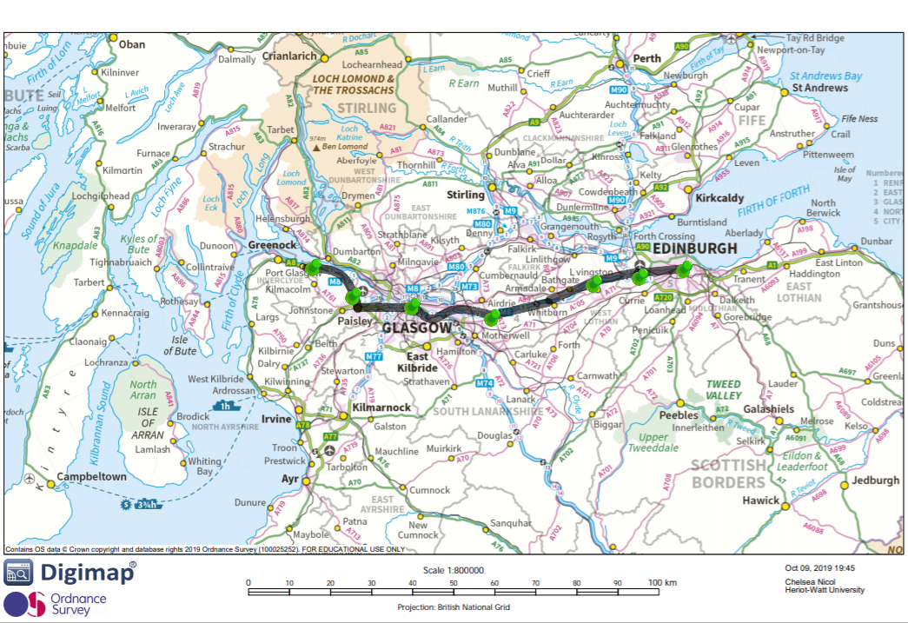
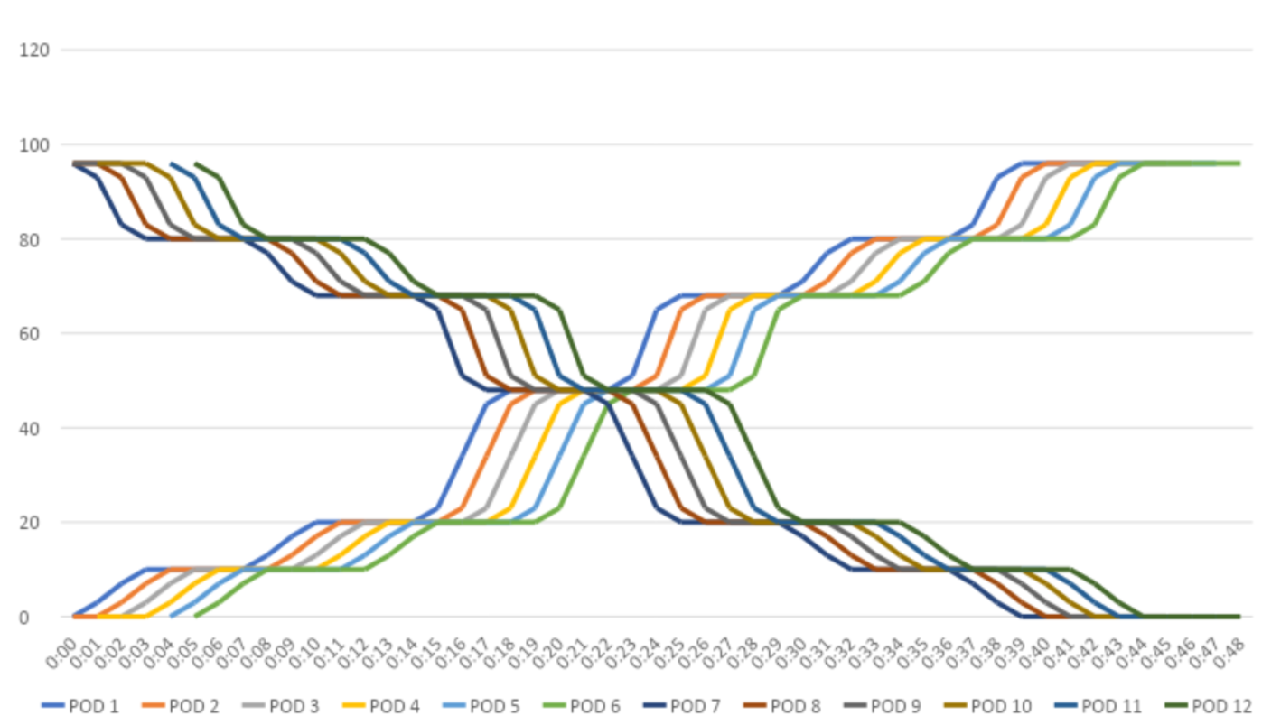
Space TIme Graph for route 3 suggested which would maximises capacity and extends the route in general.

- Fully overground route built on top of the M8. 2 lanes of the M8 closed to cars and turned into our proposed project.
- Runs from Haymarket to Port Glasgow. 7 stops in total
- Port Glasgow>Paisley>Glasgow Central>Airdrie>Livingston>Edinburgh airport>Haymarket. 39 minutes end to end with 2 minutes of safety and 4 minute stops at stations.

Pros
- Massive capacity with many stops enabling lots of places to be served by the proposed project.
- Reduces air pollution as it takes up space used by cars
- Avoids using green or built up areas as it is built on top of the M8
- Cheap and easy construction as materials can be transported by road to site
- Radical step against car dominance
- Benefits smaller cities with great links to the major hubs.

Cons
- Almost as slow as train between the main hubs (25 versus 38 minutes)
- Many stops, more energy needed to break and accelerate pods at stations
- Stations need to be built adding to costs
- Very long route, more expensive
- Not as straight as other proposals, lower top speed.
- Overground will block views in urban areas, and scenery in rural areas
- Unprecedented disruption to traditional transportation (repurposing half of the M8)

