
Origin Destination Matrix in Thousands

Trips A-B | Renfrewshire | Glasgow | North Lanarkshire | West Lothian | Edinburgh | Total B
Renfrewshire |  | 1325 | 50 | 3 | 8 | 1386
Glasgow | 167 |  | 472 | 10 | 20 | 669
North Lanarkshire | 16 | 1181 |  | 42 | 47 | 1269
West Lothian | 5 | 133 | 234 |  | 716 | 1088
Edinburgh | 7 | 127 | 117 | 327 |  | 578
Total A | 195 | 2767 | 874 | 381 | 790

- This shows the volume of people travelling from each zone on the M8 corridor.

- We can clearly see that the highest travel volume occurs from Renfrewshire to Glasgow.

- We see that the most popular location is Glasgow by a huge margin followed by North Lanarkshire.

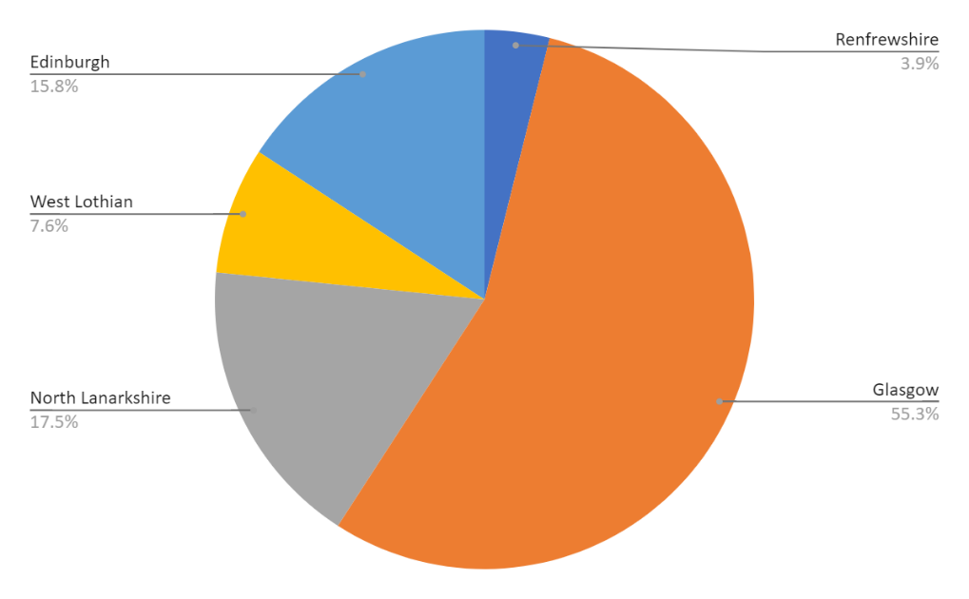
- The result might be exaggerating North Lanarkshire as the people who work there are really employed in Glasgow rather than in their local community. Census data only given employment status not job locations.

(figure 1: pie chart showing the above data in percentages)

Reflection on O/D

We wanted to “verify” the O/D findings. This was done by looking at the revealed preference of long distance (>15km) commuters from 2006.

Living/working | Glasgow | Edinburgh
Glasgow |  | 3732
Edinburgh | 2178
Renfrewshire | 357 | 7723
North Lanarkshire | 2209 | 12624
West Lothian | 15495 | 1209
Total | 21793 | 23734

- Confirms Glasgow's importance in system.

- Confirms the distribution of commuters from the smaller regions.

- Discrepancy in results due to only including long distance commuters, data is also older than census data used for gravity model.

The gravity model and O/D matrix are tools that give very rough but useful results.

If our project was implemented you could expect:

- A higher number of people commuting from West Lothian to Glasgow.

- A higher number of people commuting from Edinburgh to Glasgow.

- A higher number of people commuting from North Lanarkshire and Renfrewshire to Edinburgh.

- Edinburgh workers could take advantage of the lower housing prices in Glasgow and travel to Edinburgh more easily.

- Housing prices in Edinburgh may in turn go down and there could help balance the economy here and incur additional social benefits of cheaper housing.

- Tying the M8 corridor closer together gives more diverse opportunities for people at either ends of the central belt.

- A case study on such transport link induced change; øresund link between Copenhagen and Malmø (pop: 1.3 mill & 300k) (reduced travel time and mode changes. Our project would get the Glasgow to Edinburgh travel time down from 42 to 7 minutes)

