Route Proposal
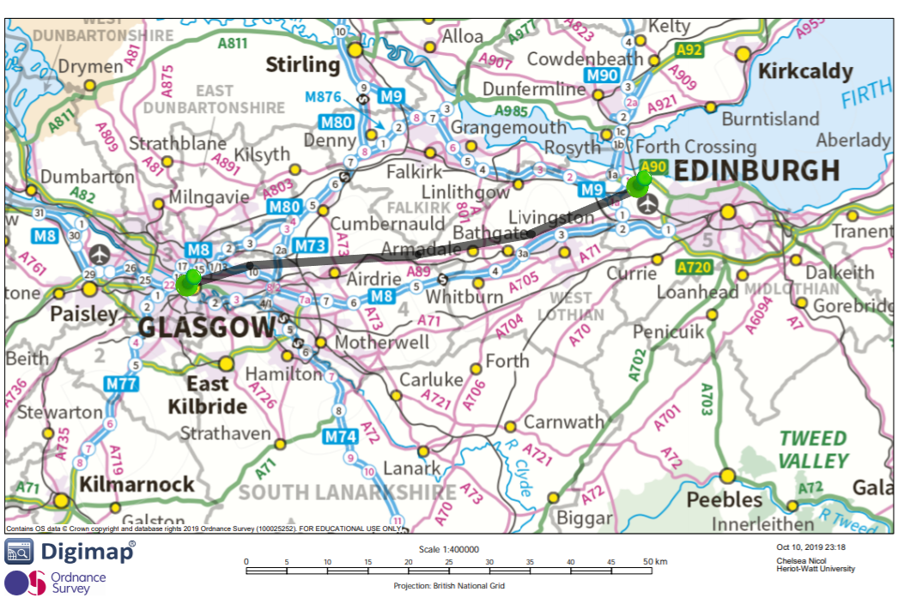

Chosen Route features

- Purpose to maximise traffic capacity between Glasgow and Edinburgh airport. Only 2 stations.

- Links onto existing infrastructure at Glasgow Central and Edinburgh airport i.e. Glasgow subway and Edinburgh Trams

- Underground in Urban areas, under Union canal and airport. While traversing urban areas, the plan is to have the track underground to avoid disturbing buildings and other infrastructure, however once it crosses into open country a cheaper above ground track will be in place.

- Minor impact on green areas when situated above ground as electric powered and no emissions, may disturb sightlines but no more than other current transport systems. Justifiable as cost is lowered and as it is suspended it’s ground footprint should be relatively small.

- Combines elements from previous proposals. Part underground part above ground. Runs from airport as proposed by geographer and urban planner. Discussion led to end station being a modified Glasgow central.

- Changes made in route direction and length of track below ground. Stations discussed are closer and thus require less track built between them.

- Route is economical, low number of stations and short so it reduces the risk of testing a new technology. If it works tube can easily be extended in both directions and stations added.

- Should be more reliable and cheaper to run than trains. Less maintenance and faster travel making it more convenient for the user.

- Tickets will be more expensive than trains but will be a good alternative for high time preference travellers with little luggage.

- 1 pod leaves the station every minute. Due to the 2 minutes spent accelerating there will be a 2 minutes difference between the pods once they are coasting. That is plenty for an emergency stop.

- Top speed will be 720 km/h

- Pods in small trains expect up to 100 people per pod

- Turnaround at station will be 4 minutes. At station passengers get off and pods take a low speed turn before loading up with passengers and getting into loop again.

Infrastructure and Engineering
- The current plan is to have a single station at each of the two connected cities. The first of which is to be at Edinburgh Airport as there is currently a plot of land on sale in a very accessible location, with the added benefit of access provided by trams from the city. As for Glasgow, the chosen location would be Glasgow Central due to its ease of accessibility for travelers. This is an expensive option however, as tunnels would have to be dug under the station to provide for the platforms of the proposed project..

- While travelling through urban areas the proposed project would be underground due to the lack of space to run new infrastructure through built up areas. This is especially the case for our glasgow connection, which is planned to be in the heart of the city. As for Edinburgh, due to the fact that the planned route does not enter the heart of the city, there is no requirement to have a tunnel be dug for the line and it can be constructed for a much lesser price. Through the countryside, again the line would be above ground so as to save on the high costs of tunneling. And there is little concern for pollution both noise and air due to the nature of the proposed project.

- We had previously estimated a construction cost per km of £120 million based on Elon Musk's own proposed project and similar high speed transport schemes in place both in the Uk and abroad. For our proposed track length of 60km this comes out to an estimated £7.2 billion pounds in total.

- This specific route has been chosen for its shorter length as this makes it more efficient, being cheaper to operate than routes with more stops and diversions. This reduces the amount of time needed to accelerate, which allows for a longer coasting time, saving energy and making this route the fastest out of all the routes proposed.

- It is faster and cheaper than comparative alternatives present at the time. By running along the M8 corridor it appeals to the same demographic that already uses these systems increasing its chances for success. Furthermore it is hoped that our proposal would support current and future demand as it is estimated to have up to a 6000 people per hour capacity to start off with, as well as being easily expanded upon to allow for greater traffic flow.

- Another reason that this route is currently our main proposal is that it cuts as little of the green as possible, while also having the added benefit of being a relatively straight route between Glasgow and Edinburgh hence reducing centrifugal acceleration and allowing for a longer coasting time.

- People have a history of being skeptical when it comes to new modes of transport due to its untested nature. To cater to potential customers and put their minds at ease we have ensured that the route is safe and the acceleration and stopping distances have been closely monitored. The cost per ticket is also comparative to current methods of transport at roughly £16.80 for a one way ticket and it is much much faster in comparison.

Human Mobility
It is most likely that our proposed project would increase human mobility to the areas it is available. The route proposed would mean that people could make the journey from Glasgow Central Station to Edinburgh Airport in just 9 minutes. Comparatively that’s 45-50 minutes by car and over and hour by conventional public transit.

This route would most likely be used by people traveling to and from Glasgow via Edinburgh Airport. This could mean that less people would use the airports in Glasgow, as it would actually be faster to travel to Edinburgh Airport from Glasgow than it would be to get to Glasgow’s own airport, that being said the cost of tickets compared to a bus ticket from Glasgow to Glasgow Airport will also be a factor to consider .

There is no existing railway station by Edinburgh Airport. Hopefully this would mean that our proposed project would not take away any passengers from the rail network and instead would be reducing the amount of cars travelling from Glasgow as well as their emissions. Both benefiting the environment and reducing congestion.

Land Use
Because the station of the proposed project would be an underground extension to Glasgow Central Station, the land use would not change there. This does run the risk of running into underground pipelines, or other forms of buried infrastructure and could pose many complications that would increase project costs in unexpected ways.

At Edinburgh airport however, the location suggested is acknowledged by Edinburgh Council as a long term redevelopment opportunity. As it stands, there is a farm located and that would have to be demolished, however it is hardly key infrastructure or contains any listed buildings and so this would likely have very little impact.

Space Time Graph For Proposed Route
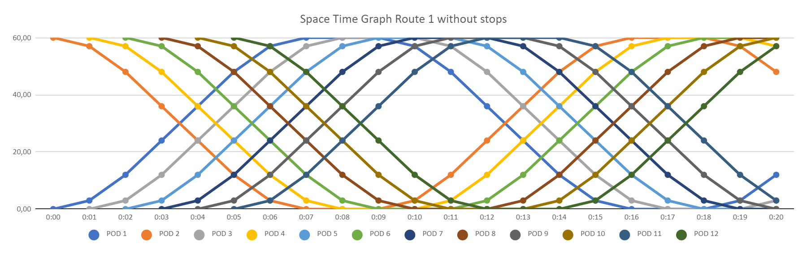
- There will be 12 pods all together.
- 60 departures per hour, one every minute
- The speed of this will be upto 720 km/h and it will accelerate safely at 6 km/h/s

This space time diagram has a much more uniform distance between the pods and hence it can be argued this is comparatively safer than the other routes proposed. This is also the fastest route as seen by this graph.

This space time diagram appeared 3 times in our proposed route because the routes were similar to the point at which the difference in the space time diagram would appear to be insignificant, hence to choose between them we had to discuss various structural features such as the location of the stations and over/underground track were deciding factors.

Other space time diagrams

Note :- A trend that is constant throughout all our ideas is a braking time of two minutes is recommended, however that is operating at max speeds. Due to this being such a small route, we can have the pods be closer than the recommended braking time when they are not accelerating or are just starting to accelerate.

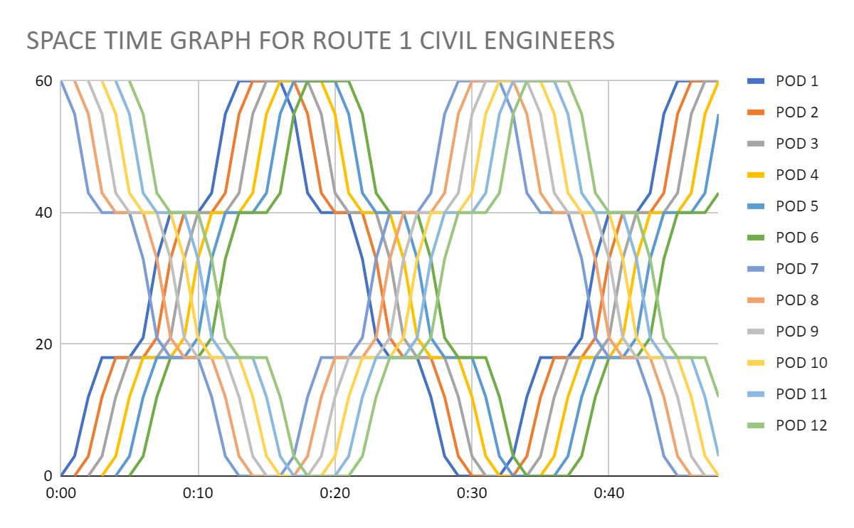
Civil Engineering Route 1 with stops at Bathgate and Airdrie between Glasgow and Edinburgh:-

From this first graph as indicated, there is a pod every minute. This idea of the route has us make the full journey in 12 minutes. Each pod stops at the stations positioned at the centre of the route for 2 minutes at the ends for 3 minutes.

Civil Engineering Route 1 without stops:-
This is the same as the space time graph for the route we chose.

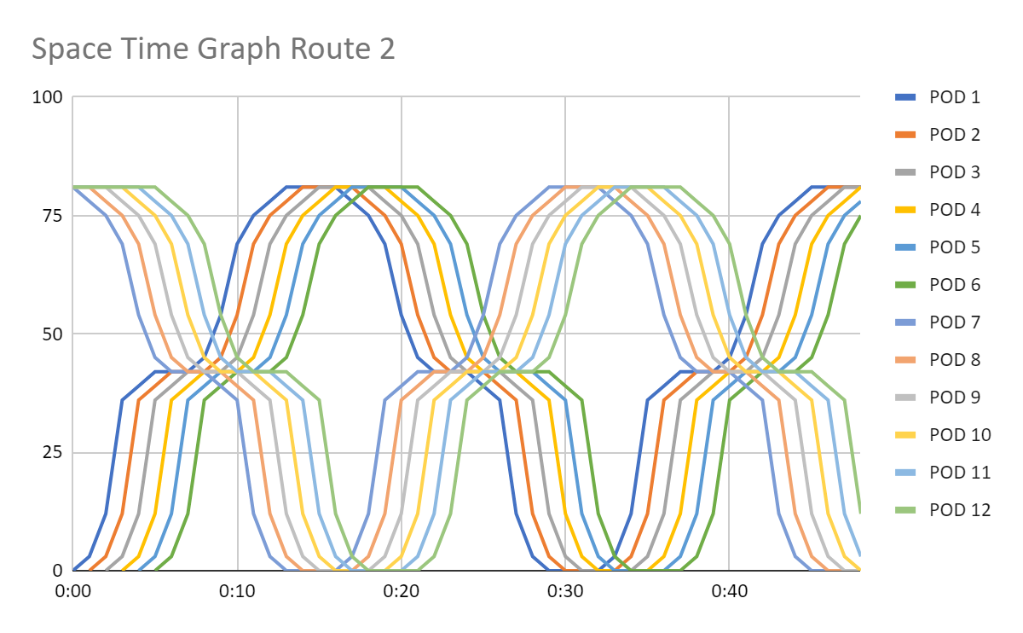
Civil Engineering Route 2 stopping at Falkirk between Glasgow and Edinburgh:-

From this graph we can see that it takes 13 minutes to complete this journey. This is with a three minute stop at Falkirk and 3 minute at each of the end stations.

Civil Engineering Route 3, 7 stops along M8:-
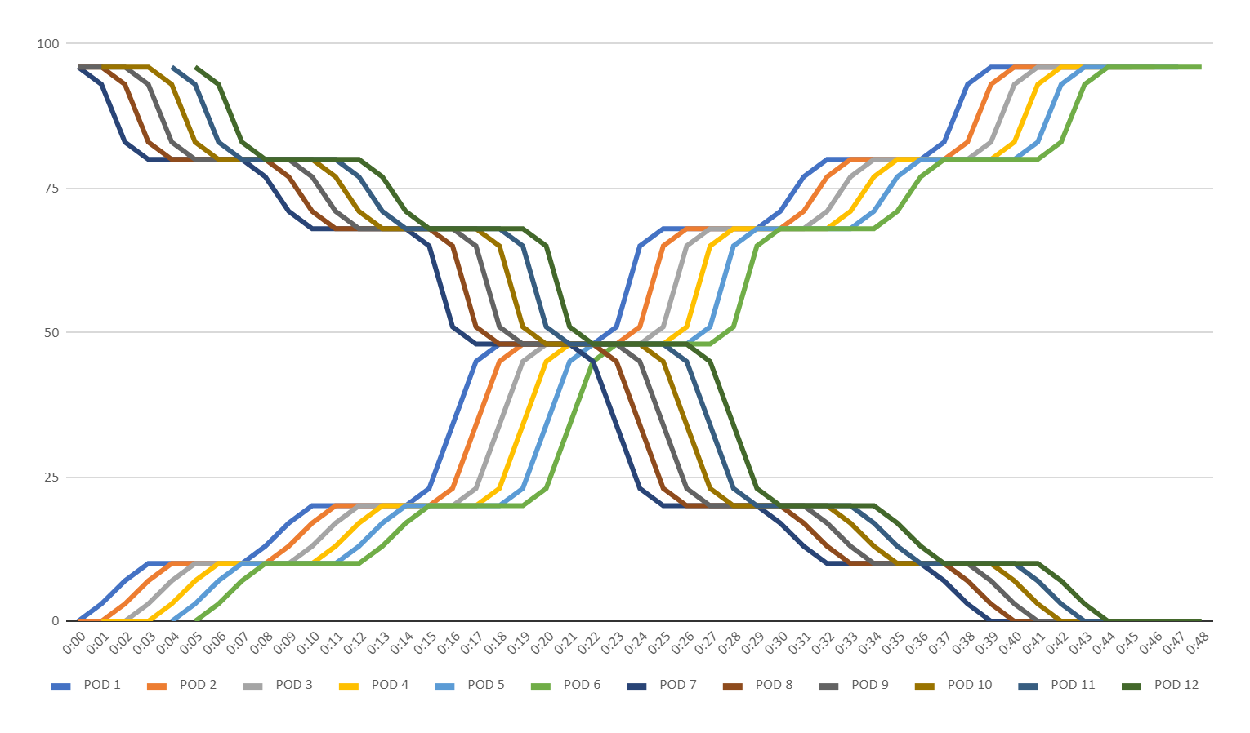
From this graph we can see that it takes 39 minutes to complete this journey. This route covers a lot of stations and stops at stations for 4 minutes each time it stops.

Geography route direct route between Glasgow and Edinburgh:-

This is the same as the space time graph for the route we chose.

Urban Planning route, direct route between Glasgow and Edinburgh:-
This is the same as the space time graph for the route we chose.

