Urban Planning Proposed Route LÖÖPS
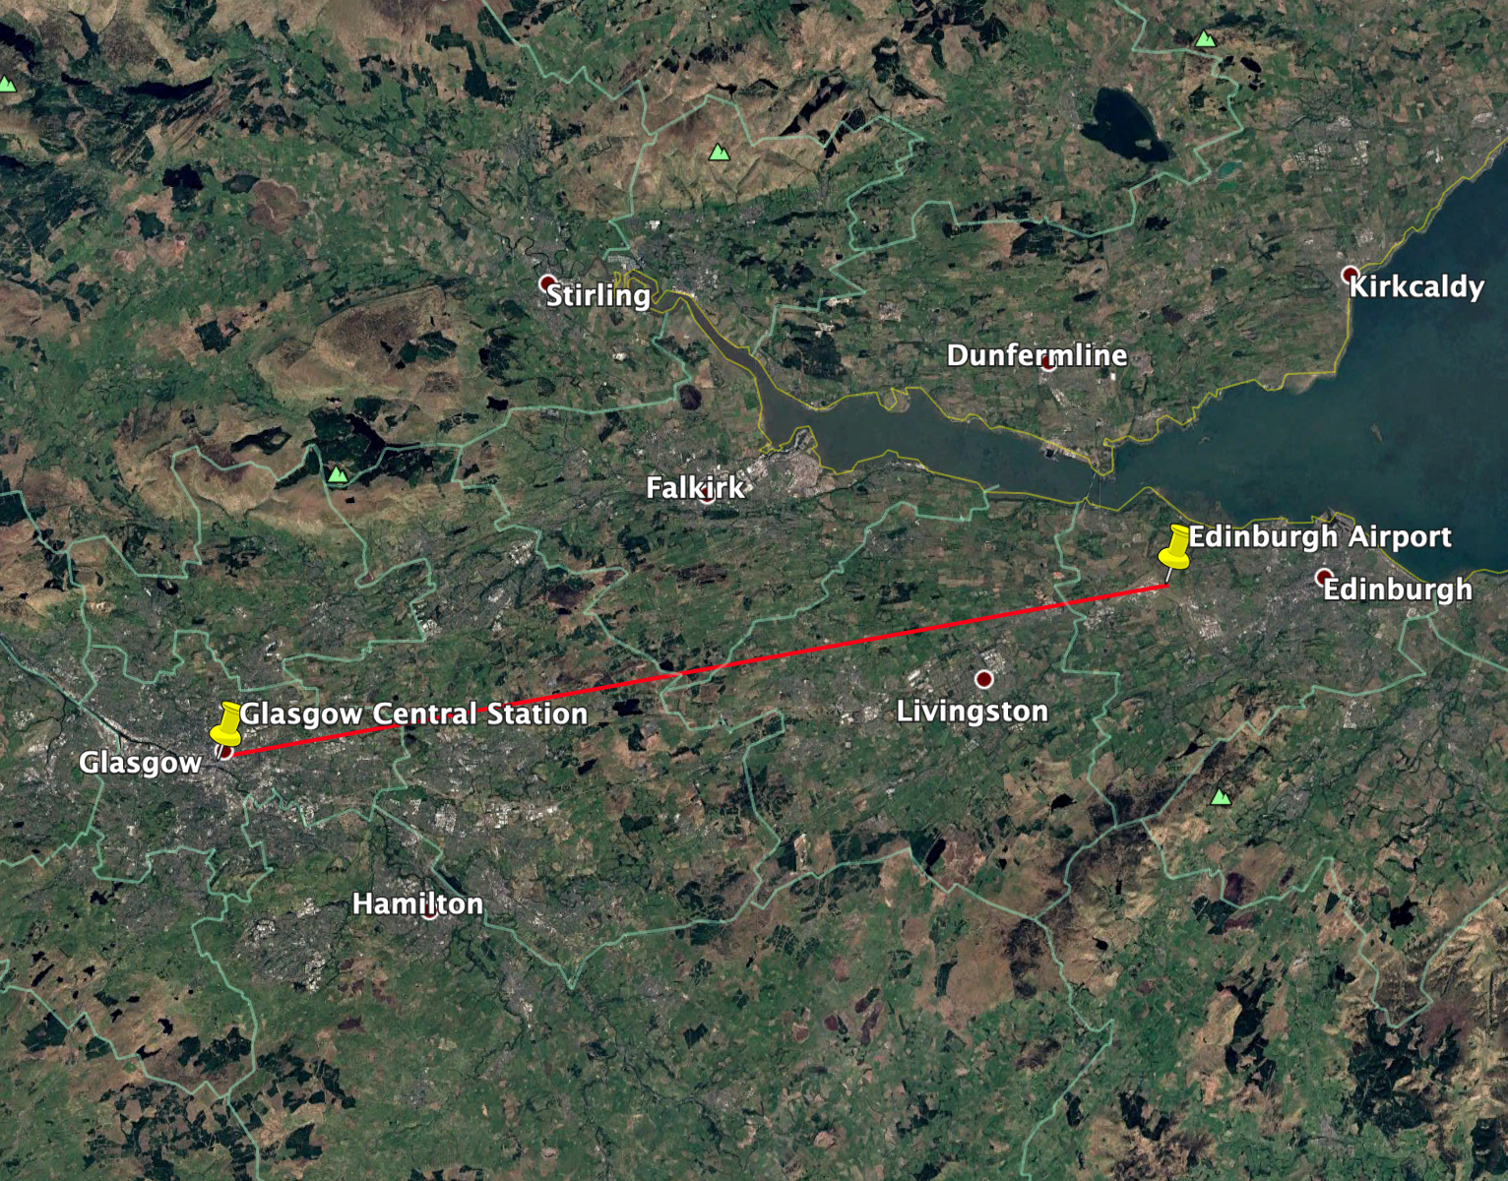

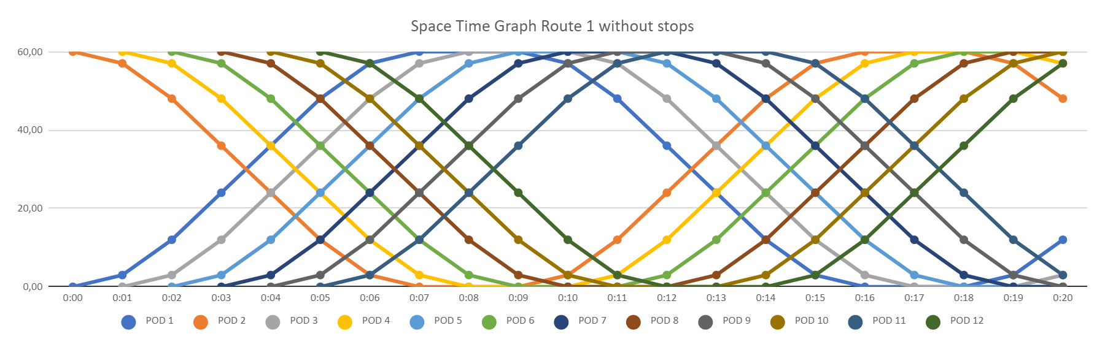
Space Time graph for route suggested
The proposed route for the hyperloop from the urban planning perspective run from Glasgow Central Station to Edinburgh airport. With Glasgow Airport being very far out of the city, this new line could eventually mean that people from Glasgow easily can get to Edinburgh airport, which would be a great foundation for eventual development at Edinburgh airport. It is important to have both hyperloop stations at locations which are well connected. At Glasgow Central Station, you have connections with long and short distance trains, buses and the subway, and at Edinburgh Airport travellers can easily transfer to both the tram and buses which will take you into the town centre. No stops are proposed on this route since there already are trains in between the cities. Furthermore, the attractiveness of the hyperloop comes from the speed, and with stops in between, the ticket price and efficiency would not be justifiable.

It would also be proposed to have the entire route underground, as this would have as little of an impact on the settlements and green belts that are in between Glasgow and Edinburgh.
The negative aspects of this route would be the cost of having it underground. Building a 36 miles long route underground, especially in the sections with limited road accessibility, would mean large costs. It would also be a safety risk, and emergency exists would have to be built along the entire route.

