We estimated costs of funding being sought from Transport Scotland to be £1,238,000.00, this includes the costs of salaries, testing equipment, other equipment (levelling etc.), transport and access costs. In monthly increments this would be £51,583.33 per month for the two-year contract. These costs are approximately 45.3% of the maximum funding available. Look at Figure 3.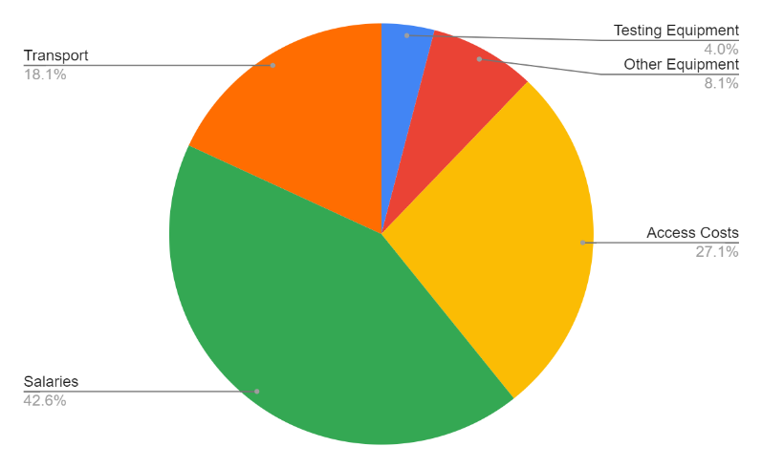

Figure 3: Pie Chart of how the proposed money will be spent.
As it stands the Shanghai maglev (£32 million per km) is the most comparative existing technology to our current hyperloop proposal. In the UK however HS1 and HS2 are our most similar schemes (£51.3 million per km, and £250 million per km respectively). Therefore in order to estimate our costs for a hyperloop system we must combine existing estimates and the HS rail costs found in the UK. Ironically enough, despite the untested and developmental stage that Hyperloop finds itself in, the estimates for a system in California are also cheaper than what is being poured into HSR in the UK (£40.7-64 million per km).
Realistically, this developmental stage could result in costs as high if not higher than that of HS2. Were it to cost the same per km as the upper estimates for HS2 of £250 million per km, our Hyperloop track could cost as much as £17 billion as the crow flies or approaching £19 billion following a similar route to that of the M8, give or take an extra 300 million for legal fees when negotiating over land rights or station construction. This is however an incredibly high estimate.
Were it to be built at the same cost as Elon Musk’s own Hyperloop estimates at approximately £41 million per km (SpaceX, nd), the overall cost would be between £2.7 and £3 billion. This is a potential lower limit, and frankly a rather generous estimation considering the cost that HS1 and HS2 came in at. A middle ground of around £120 million per km (more than double HS1 and Hyperloop estimates, but far lower than the overly inflated 250m from HS2) gives us the figures of a total £8 or £9 billion as an overall construction cost for our Hyperloop proposal.
This estimate does not include any of the potential in-kind funding we hope to receive due to the large-scale impact the project will have. We believe that we will receive knowledge and input from the local council and government officials who will be invested in what we are doing. We also hope that we can gain recognition from the media and people with large platforms, building our public engagement and anticipation of the project. We are looking into using recycled material donated to us by local contractors, this would cut down their costs as they would not have to pay landfill tax and would cut our costs as we would have to spend less on raw materials.
Give locals, who are interested in construction, the opportunity to volunteer in a professional capacity by working on this project.
As well as promoting what we stand for and represent, this will engage the younger generation to do something substantial and leave a lasting impression. This can lead to an increased interest in fields such as Urban Planning, Geography and Engineering. We hope in doing this, we not only save on labour costs but inspire a new generation and encourage more women to get into STEM subjects

Costs. Broken down over two years in monthly increments

- Site visits ¬ £100- (£200 in city) per visit for 2 hours ¬ roughly 40 different visits throughout the feasibility study and 16 in the city. 4000+3200=7200
- Equipment Leveling ¬ £5000 to £10000= 10000
- Stimulation/access¬ £7000 per month 168000*2 =336000
- Testing equipment ¬nth * 7 £4000 per month * 2 for CEO Project manager =528000
- roughly £200 dependent on test, let's say 200 tests done=40000
- Salaries ¬ £2000 per moChecking opinions ¬ £2000 per opinion, 100 opinions=£200000
- Transport costs ¬= 224000

